**PJ 7 Report My Name: _Yaowei Lei__**

**A. The following is my Python source program:**

**// Please copy your source program into here from your Visual Studio IDE.**

**// Your code here must be in color. You must not show screen prints here.**

#-----------------------------------------------------------------------------------------------------------.

# Author: Yaowei Lei

# Date: 11/20/2021

# Purpose: CS119-PJ7: Super Calculator – to perform 6 mathematical operations for 2 numbers.

#-----------------------------------------------------------------------------------------------------------.

def addition(n1, n2) :

return n1 + n2

def subtract(n1, n2) :

return n1 - n2

def multiply(n1, n2) :

return n1 * n2

def divide(n1, n2) :

return n1 / n2

def power(n1, n2) :

return n1 ** n2

def modulus(n1, n2) :

return n1 % n2

def check(n1, operator, n2) :

# exception: operator not valid

while (operator != "+" and operator != "-" and operator != "*" and operator != "/" and operator != "**" and operator != "%") :

operator = input("Enter a valid operator: ")

# exception: n2 = 0 when operator = / or %

if (operator == "/" or operator == "%") :

while (n2 == 0):

n2 = float(input("Enter your second number which cannot be zero: "))

# evaluate the result if operator is vaild

print ("Result: ", n1, " ", operator, " ", n2, " = ", evaluate(n1, operator , n2))

# return the result

def evaluate(n1, operator, n2) :

if (operator == "+") :

return addition(n1, n2)

elif (operator == "-") :

return subtract(n1, n2)

elif (operator == "*") :

return multiply(n1, n2)

elif (operator == "/") :

return divide(n1, n2)

elif (operator == "**") :

return power(n1, n2)

elif (operator == "%") :

return modulus(n1, n2)

# Beginning of MAIN PROGRAM ============================================.

n = 1 # line number for each separator line

print ("Welcome to the Super Calculator of Yaowei Lei!")

print (n,"============================================================"); n+=1;

while True: # keep running forever. It must be stopped by a break inside the loop.

n1 = float(input("Enter your first number: ")) # input the first number as a float

operator = input("Enter your operator: ") # input a operator

n2 = float(input("Enter your second number: ")) # input the second number as a float

# @ for stopping the calculator game

if (operator == "@") :

break

# calculate the result

check(n1, operator, n2)

print (n,"============================================================"); n+=1;

print (n,"============================================================"); n+=1;

print("Thank you for playing this Super Calculator of Yaowei Lei!")

print (n,"============================================================"); n+=1;

# End of MAIN PROGRAM ============================================.

**B. The following is the console output of my 3 test runs:**

**// Please copy your console output and paste into here:**

**Test Run #1:**

**文本

**

**Test Run #2:**

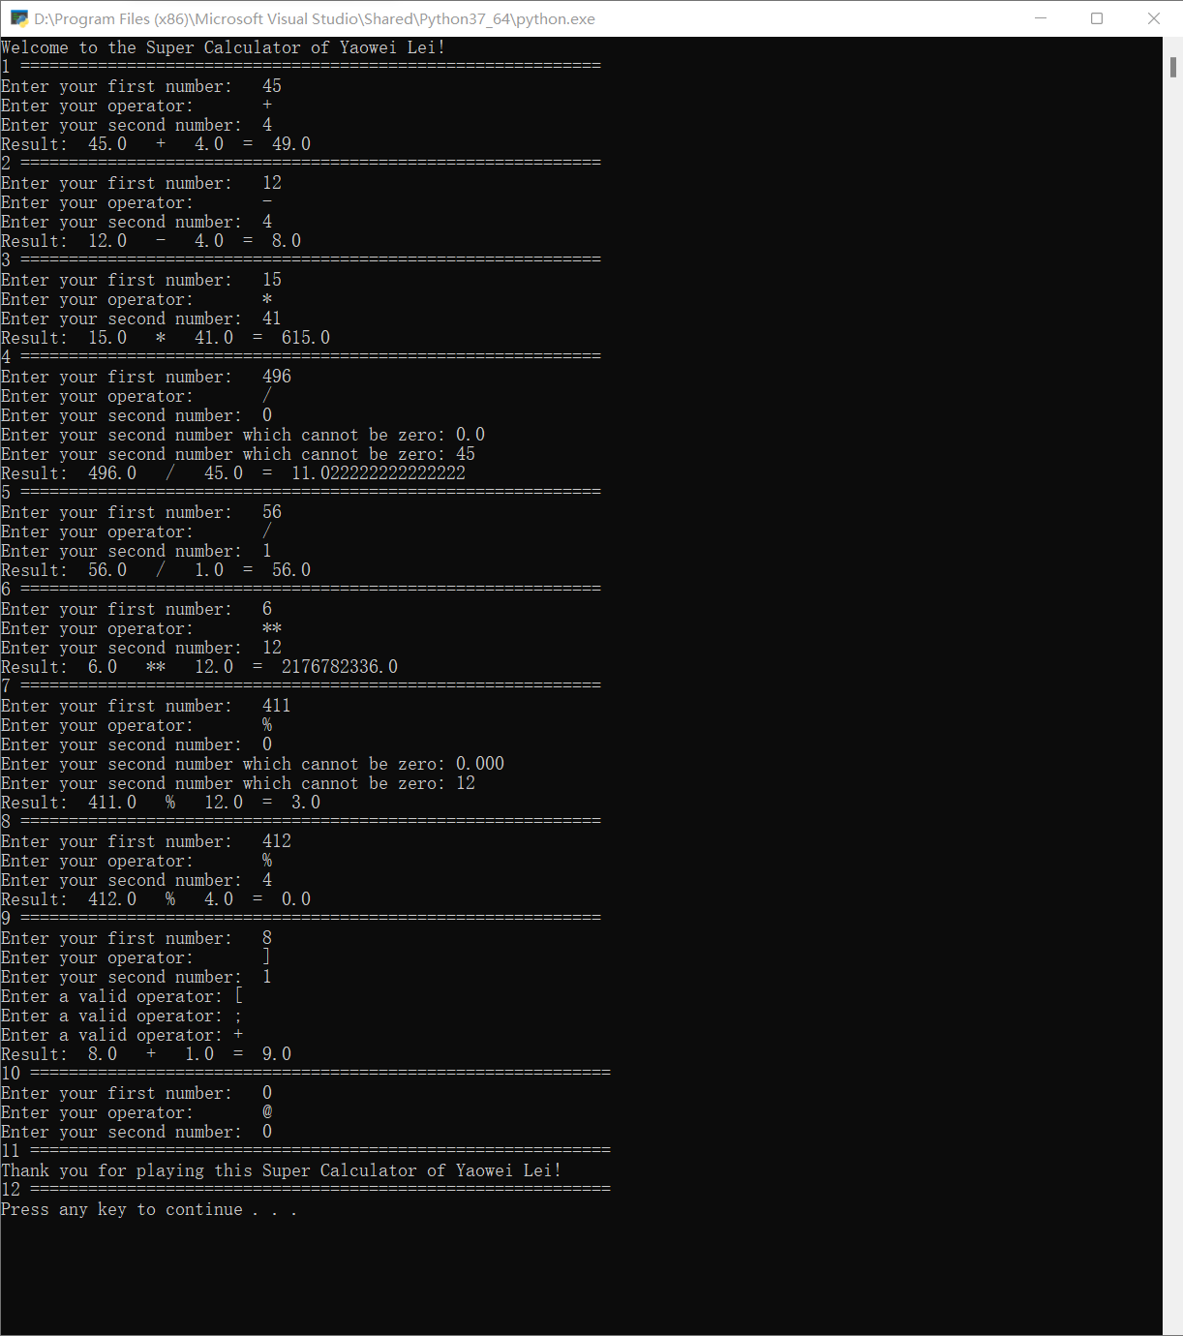

**Test Run #3:**

